We asked doctors: Should Massachusetts voters legalize magic mushrooms?
Henry Schwan
Worcester Telegram & Gazette
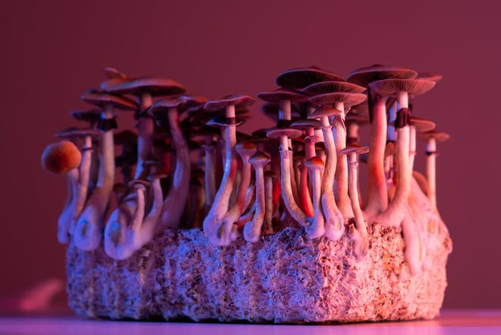
WORCESTER ― The topic of so-called “magic mushrooms” is getting a lot of attention.
Massachusetts voters will decide in November whether to legalize access to five types of natural psychedelics — some of them found in mushrooms, others in plants — for ages 21 and older that advocates say are effective in alleviating mental health and substance-use disorders.
The politics of Question 4 has its supporters and detractors. However, the report will focus on the medical side of the issue, with perspectives from doctors working in emergency medicine, toxicology and psychiatry.

Not enough evidence
One consistent message from some doctors is that while psychedelics have been used recreationally for decades for their hallucinogenic effects, it’s too early to tell if they’re safe and offer medical benefits because there haven’t been enough studies.
“It would be a huge mistake to be on the ballot,” said Dr. Anthony Rothschild, professor of psychiatry at UMass Chan Medical School and editor in chief of the Journal of Clinical Psychopharmacology. “We don’t know if taking psychedelics is effective for depression or PTSD (post-traumatic stress disorder). We don’t know the side effects, short-term and long-term.”
The psychedelics in Question 4 include psilocybin, psilocin, dimethyltryptamine (DMT), ibogaine and mescaline.
Early studies of psilocybin have been linked to suicidal thoughts, said Rothschild, adding that it's unknown if those thoughts were related to the drug. He also noted a study set to appear in the November issue of the Journal of Clinical Psychopharmacology will reveal 78 total illnesses including 40 hospitalizations across 28 states and at least two deaths, potentially related to psychedelics through the first seven months of this year.
Those numbers relate to products sold under the Diamond Shruumz brand. According to federal officials, they contain higher than expected amounts of muscimol, a chemical found in some mushrooms. Muscimol is not one of the five psychedelics in Question 4.
Get the Afternoon Headlines - Worcester MA newsletter in your inbox.
Our top stories of the day delivered every afternoon
Delivery: Daily
Your Email
Meanwhile, the Veterans Administration is conducting research on certain psychedelic compounds including psilocybin and MDMA, commonly known as ecstasy, to treat PTSD and depression among veterans.
"Through this research, VA intends to gather rigorous scientific evidence on the potential efficacy and safety of psychedelic compounds when used in conjunction with psychotherapy," said Terrence Hayes, VA press secretary, in a prepared statement. "These studies will be conducted under stringent safety protocols and will mark the first time since the 1960s that VA is funding research on such compounds."
MA Ballot Question 2024: How Question 1 would change the power of the state auditorMCAS Question: What will and will not change if Massachusetts voters approve Question 2?Will rideshare drivers be allowed to unionize? Here's what to know about MA Question 3How (and when) Question 4 would allow natural psychedelic substancesMassachusetts tipped workers' minimum wage is lower. Ballot Question 5 could change the pay
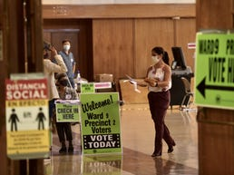

'Remarkably safe'
Dr. Franklin King has a different take on natural psychedelics. He believes that plenty of research shows they are “remarkably safe” from a medical standpoint.
King is a psychiatrist at Massachusetts General Hospital and a supporter of Massachusetts for Mental Health Options, the group that is leading support of Question 4. None of the five psychedelics are addictive, according to King.
Not so, said Dr. Nassir Ghaemi, a professor of psychiatry at Tufts University School of Medicine and president of the Massachusetts Psychiatric Society’s executive committee. Ghaemi noted that psychedelics can leave users feeling better physically but often come with a psychological addiction.
King acknowledged that some physicians feel certain patients shouldn’t take psychedelics including patients who can’t tolerate a slight increase in blood pressure and those who are medically frail.
From a psychiatric standpoint, King said, many physicians believe those suffering with schizophrenia and bipolar disorder type 1, commonly known as manic depression, should not take psychedelics. Ghaemi explained those living with those two mental health disorders naturally hallucinate. But if they take psychedelics, they could have hallucinations that turn to suicidal or homicidal thoughts.
That is a disturbing thought, said Ghaemi, since roughly 3% of the Massachusetts' population has schizophrenia or bipolar disorder. “If they’re exposed to hallucinogens, then they're likely to get much worse in a dangerous way,” he said.

Risks are everywhere
King said the health risks from alcohol are more problematic than those posed by many schedule 1 drugs classified as ill-suited for medical use including psychedelics. There’s also preliminary evidence, according to King, that cannabis, a schedule 1 drug, poses significant risks of psychosis compared to psychedelics.
“Nothing is risk free,” said King, who believes education is needed to inform the public about where psychedelics rank against what is already legally available. If that happens and some psychedelics are decriminalized, doctors and their patients can have honest conversations to achieve the best health decisions.
“The point I'm making is about cutting harms," said King. "When things are done illicitly underground, there’s a higher risk of harm compared to what is done in the light of day.”
Dr. Powell Graham, a toxicologist and assistant professor of emergency medicine at UMass Chan, warned that taking psychedelics can lead to a trip to the emergency room, where medications may need to be given that don't mix well with psychedelics that are already in a person’s system. The result could be an impact on the brain, increased body temperature and muscle breakdowns that can injure the kidneys.
There are also life-and-death situations. Ibogaine, one of the psychedelics covered by Question 4, is known to cause sudden cardiac death, said Powell, and it can happen 24 to 36 hours after ingesting the psychedelic due to abnormal heart rhythms.
Graham said that in his seven years at UMass Chan, he has only seen one or two patients with severe psychological distress after taking psychedelics.

'Bad things can happen'
Ghaemi cautioned that hallucinations can turn dangerous. One of his patients was in a coma for two months after taking the psychedelic Ayahuasca, which was administered by a shaman. The patient's mother, who wished to remain anonymous, said her child is still recovering. She wants the public to know that if psychedelics are taken while not properly monitored and regulated, "bad things can happen."
Ghaemi believes Question 4 doesn't provide the necessary supervision because the licensed therapeutic centers where the public would access the five psychedelics don't have a staff of trained doctors, nurses and social workers. Question 4 says psychedelics would be administered under the supervision and guidance of a trained, licensed professional at regulated therapy centers.
The ballot question also calls for homegrown psychedelics in a maximum space of 12 feet by 12 feet, provided no one younger than 21 can have access to the space.
Ultimately, Massachusetts voters will decide whether to follow Colorado and Oregon as the only states to legalize some psychedelics. As UMass Chan's Rothschild sees it, that can't happen until more robust scientific studies are done to prove that psychedelics are safe.
"From a medical standpoint, we don't know if they work and we don't fully understand the side effects," said Rothschild. "I'm all for new treatments, but they're not ready to be released to the general population. It's too dangerous."
King's opinion is there is ample research that shows psychedelics are safe, that the substances listed with Question 4 are not addictive and they're safer than other schedule 1 drugs including cannabis.
"Compared with every other illegal drug, the safety profile of psychedelics is relatively impressive," he said.

